**SPH3U 13.6 Power Plants and the Electrical Grid**

1. **Transmission efficiency**

|  |  |
| --- | --- |
| Power loss: |  |
| equation |  |
| efficiency |  |

A generator produces 300 MW (3 x 108 W) of power at a current of 30 kA and a voltage of 10 kV. That power travels through a transmission wire with a resistance of 0.1 Ω. How much power is lost (in MW and in % of the total)?

Now a step-up transformer is used to increase the voltage to 100 kV before sending it over the wire. This lowers the current to 3 kA (VPIP = VSIS). What is the new power loss?

1. 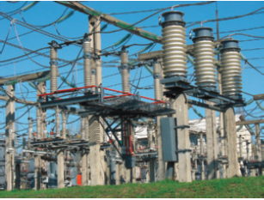**The power grid**

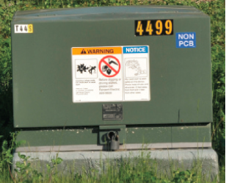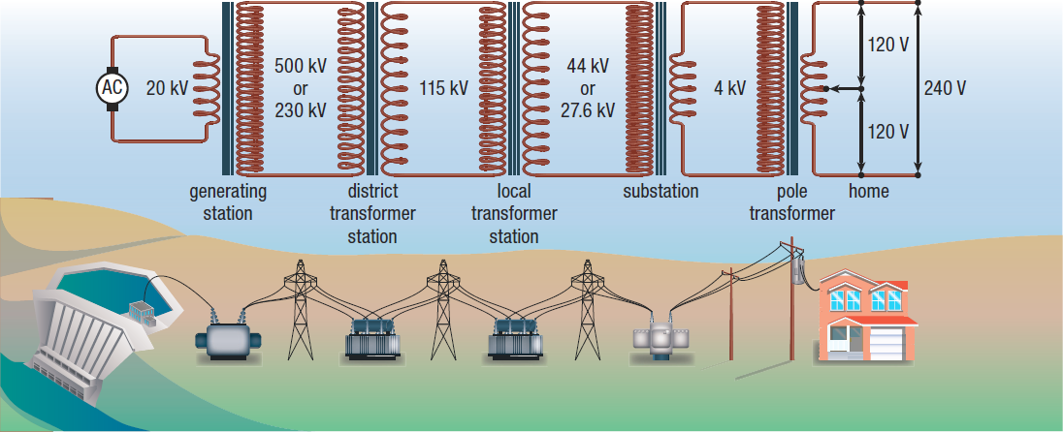

|  |  |
| --- | --- |
| AC generators: |  |

**Homework:** page 612: #1-2